Winery Row - Paso Robles, California
A master planned development that includes a 100-room resort,
16 wineries, 2 restaurants, a 350-person event center and an RV park

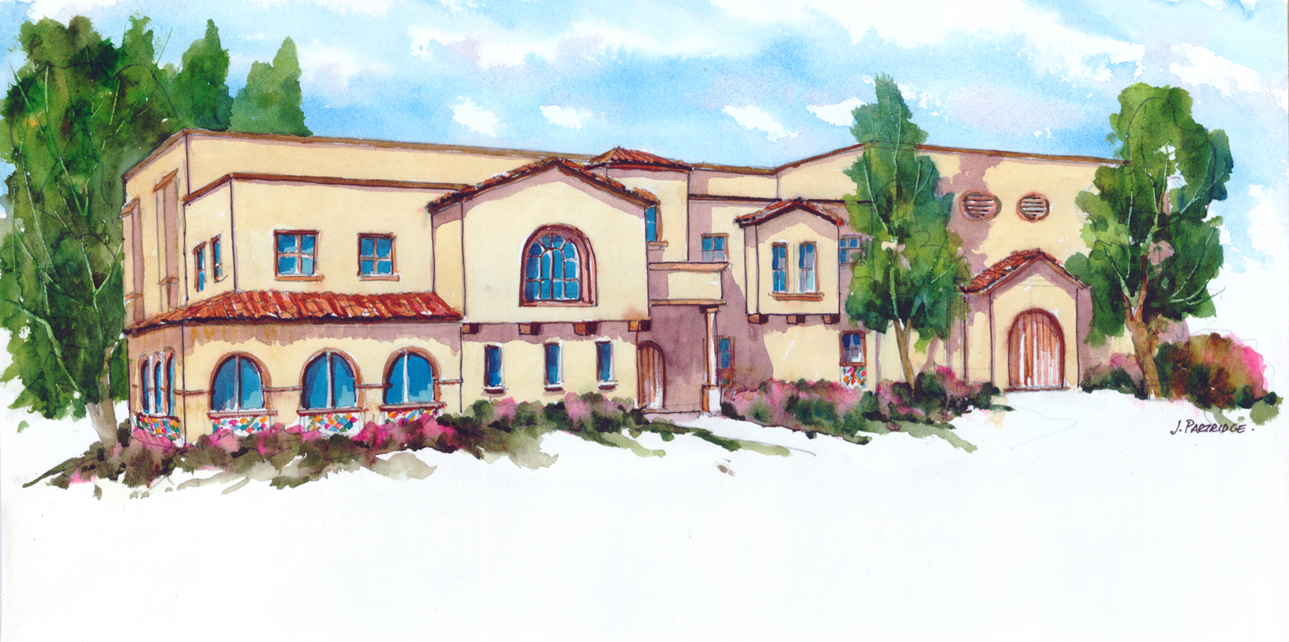

Opportunity

Throughout California, there are far more wine producers than wineries. Currently, 70% of California’s wine makers purchase grapes from vineyard managers and truck them to commercial “co-op” wineries for processing. After fermentation, the wine is stored in barrels, bottled and ultimately sold to consumers. Although this system enables a wide variety of wine makers to participate in the wine industry, it comes at a substantial price: reduced quality, poor control and high cost.

The annual grape harvest lasts just eight weeks. As a result, dozens of wine makers fight for space and equipment in commercial “co-ops” during the months of September and October. For most, the lack of equipment interrupts the wine making process and compromises the quality of the wine. For many, the lack of space dictates the grape harvest itself – resulting in fruit that has been picked prematurely, or left on the vine too long.

Demand for small-scale wineries, coupled with increased wine consumption in markets around the world, has created a unique opportunity to earn substantial profits in the commercial real estate sector of California’s wine industry. Winery Row will take advantage of this market niche by offering small-scale wineries a comprehensive and cost-effective wine processing solution never before available in the industry. Our concept has received praise from wine makers, wine tourists, the Chamber of Commerce, and the Paso Robles City Council.

“This is a very forward-thinking developer, and this project will only help build the reputation of Paso Robles as the place to visit and buy great quality wine.”
Mike Gibson, President
Paso Robles Chamber of Commerce

Winery Row

Winery Row was designed to meet the needs of the Paso Robles wine industry, and serve as the ultimate destination for wine tourism. Upon completion, the project will feature sixteen 10,000 Sq. Ft. full-service wineries, a state-of-the-art process waste facility, a 350 seat event center, two restaurants, and a host of retail offerings. Plans on the adjacent parcels call for a 100-room boutique hotel, a 25-unit Airstream motel, a 20-room tree house bed and breakfast, an RV resort capable of accommodating 150 luxury motor coaches, and a world class Equestrian Center.

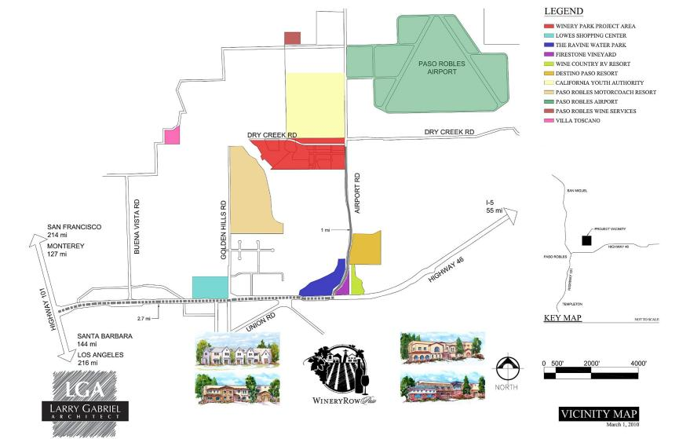

Winery Row is located in Paso Robles – in the heart of California’s Central Coast Wine Region – directly across the street from the Paso Robles Regional Airport. The property enjoys close proximity to several established, world-renowned wineries including J. Lohr Vineyards & Wines, EOS, Vina Robles Vineyards and Eberle Wines.

Paso Robles

The City of Paso Robles is located 215 miles north of Los Angeles and 210 miles south of San Francisco on Interstate 101 in California’s Central Coast. In an effort to flee metropolitan congestion, people began flocking to Paso Robles in the early 1990’s. Since 1993, Paso Robles has experienced sustained annual growth of over 10.6 percent; the longest run of uninterrupted growth in the Tri-Counties area. Today, Paso Robles has over 30,000 residents.
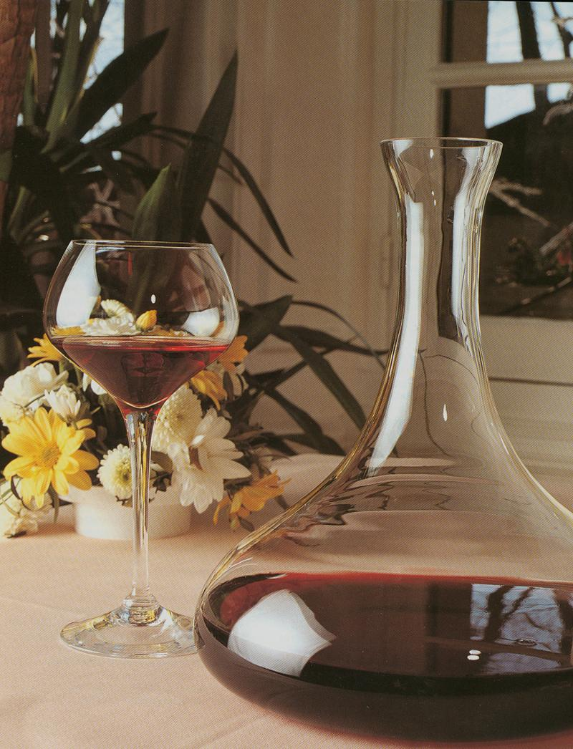
In 2014, Paso Robles was voted the Best Wine Region in America. Understandably, the wine industry has had a significant impact on manufacturing in Paso Robles, as this sector represents 23.2 percent of the local economy. With over 30,000 vineyard acres and 248 Bonded Wineries, the Paso Robles wine industry ranks third largest in California, behind Napa Valley and Sonoma County. The wine industry is California’s number one finished agricultural product, and provides a fiscal impact of $51 Billion annually.

The Challenge

Due to robust growth and the specialized nature of wine processing facilities, approximately 70% of the wine makers in Paso Robles have found it impossible to locate suitable space for wine processing and barrel storage. Unless they develop a facility of their own, most are relegated to fight for space and equipment at large co-op “Custom Crush” facilities, or operate within the strict confines of traditional “brick and mortar” wineries.
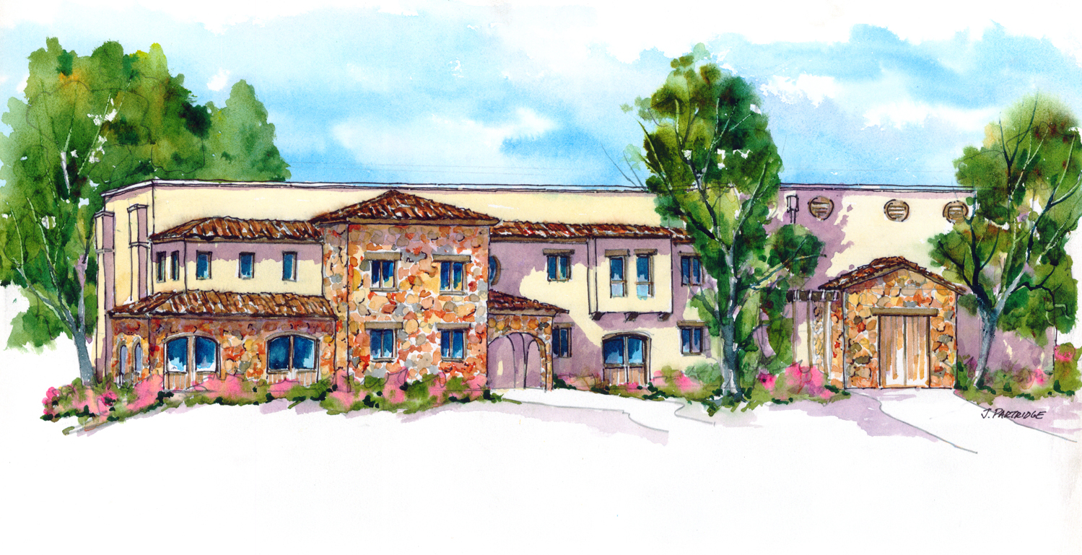
Wine makers that process their fruit at traditional wineries and co-ops, pay “a la carte” for services such as table sorting, grape crushing and de-stemming, pressing, tank and bin rental, barrel storage, case good storage, etc. After processing, storing and bottling their wines, wine makers must then market and sell them – usually by leasing space in a local tasting room. This process is very expensive. A small wine maker can routinely expect to pay $400,000 to process, store and market a 200-ton harvest.
As wine makers develop their brand and buy equipment, they tend to outgrow the limitations imposed by co-ops and traditional wineries. Wine makers hoping to strike out on their own, quickly discover that few options exist. In addition to the capital required to build a winery, the multi-year approval process requires expertise in the design of wastewater treatment systems, drainage systems, HVAC systems, humidification systems, glycol systems, etc. As a result, the winery permit process can be overwhelming.
The Solution
As a resident of Winery Row, each wine maker can process his wine, store his barrels, operate his tasting room, and put his name on the building – all at less than 50% of the cost of using co-ops or traditional wine processing facilities. In addition to providing an economical alternative, Winery Row will provide a steady stream of wine tourists looking for previously undiscovered wines. It is estimated that 1,800 to 2,500 tourists will visit Winery Row each week. A steady stream of tourists will help wine makers build their customer base, expand their wine club membership and sell more wine.

Winery Row is a Master Planned Development:

- Dining: Two full-service restaurants will be built at the entrance to Winery Row and cater to both hungry tourists and Winery Row tenants.

- Winery Row: Sixteen 10,000 square foot wineries; each including a crush pad, a 4,000 square foot wine processing area, a 3,800 square foot barrel storage facility, a 1,000 square foot tasting room, 1,000 square feet of office space, a 200 square foot laboratory, a covered patio, and direct access to a state-of-the-art process waste system. As a result, winemakers can simply lease a winery, move-in, and begin producing, storing, and selling their wine.

- The Vines at Winery Row Event Center: A 350-seat amphitheatre will be built on a beautiful four-acre parcel, which will include a bridal suite, a sparkling lake, and two cascading waterfalls. The event center will be booked for private events such as weddings, corporate functions, and concerts. In addition, each Winery Row tenant will receive one free weeknight per quarter to host wine tasting events for their customers and wine club members.

- Equestrian Event Center: The Paso Robles Horse Park, a 67-acre facility designed to host a dozen equestrian horse shows each year, will open in February of 2015.
- Tree House Bed and Breakfast: Designed for adventurous tourists, Winery Row is teaming up with Ron and John Daniels – stars of the hit TV show “Redwood Kings” to develop the first tree house bed and breakfast in America.

- Hotel: A 100-room boutique hotel will be built to accommodate tourists visiting Winery Row. The resort will include banquet facilities, a fitness center, an infinity pool overlooking the Huerhuero river valley, and a private vineyard.

- RV Resort: A 15-acre RV resort will be conveniently located within walking distance of all Winery Row amenities. Beautifully landscaped and spacious lots will provide accommodations for 150 luxury motor coaches.

- Airstream Motel: A 25-unit Airstream motel will be built adjacent to the RV resort. Each Airstream will be completely renovated with full size bathrooms, luxurious accommodations and modern conveniences such as flat screen TV’s.

- Shopping: A 15,000 square foot Tuscan inspired shopping village will be built between Winery Row and the 100-room boutique.

Winery Row

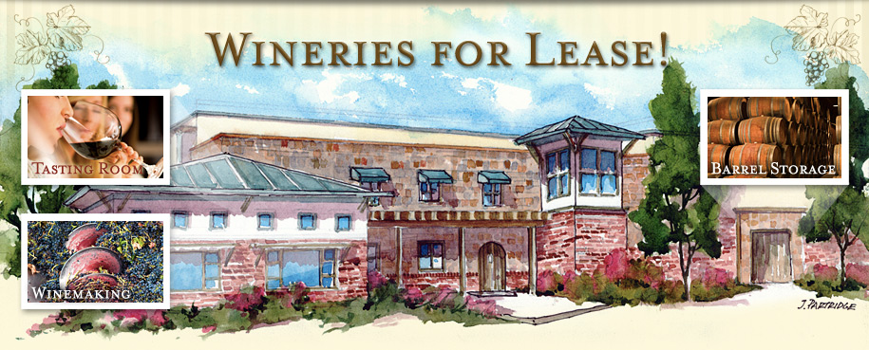

Each winery on Winery Row will feature a unique architectural theme such as Spanish Revival, Tuscany, Craftsman and French Normandy:

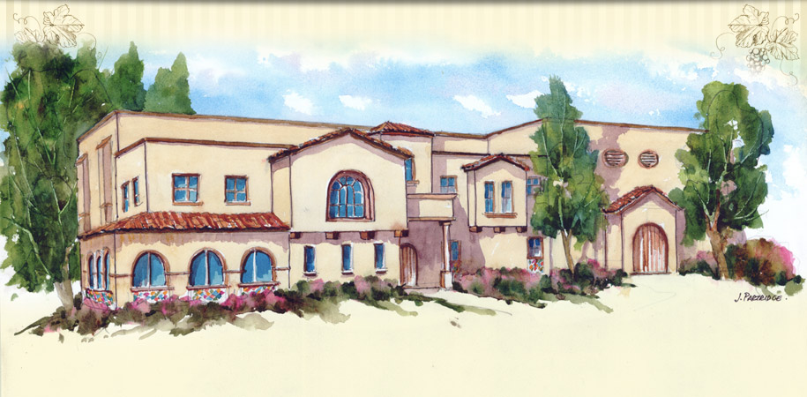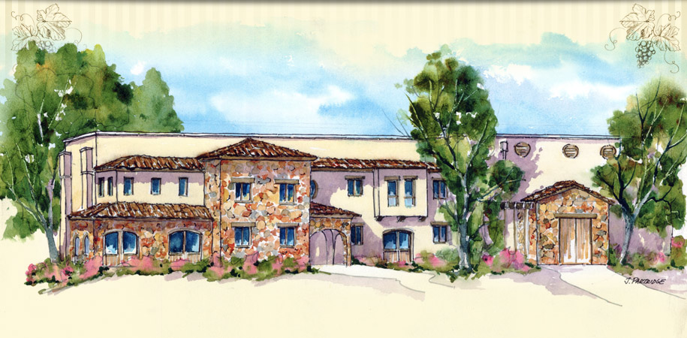
Spanish Revival Tuscany

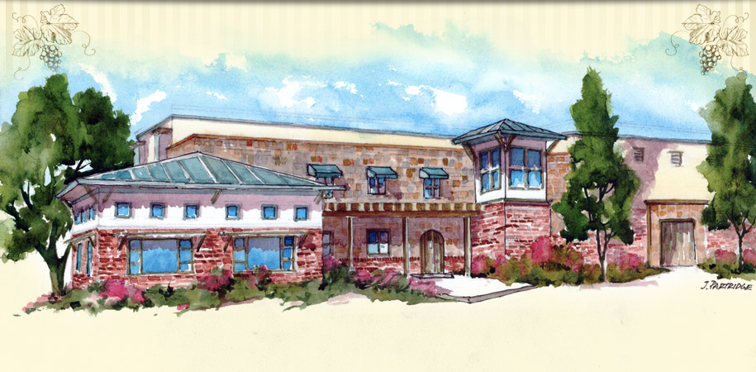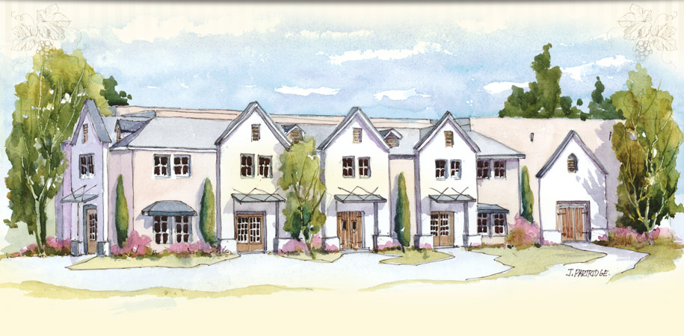
Craftsman French Normandy

Lush landscaping, designed to complement each architectural style, will add to the look and feel of each facility, and a wide meandering sidewalk, bordered by grapevines, will provide a leisurely path from one winery to the next.

Working drawings for the first winery on Winery Row are nearing completion, and construction is expected to begin in 2015. This winery will serve at the Model for Winery Row.
As the next six wineries reach completion, qualified winemakers will lease them for 10 years at the initial “triple net” lease rate of $1.50 per square foot ($18.00 annually). Accordingly, each building will generate approximately $180,000 in annual cash flow, and achieve a market valuation of $2,570,000 based on a 7% Capitalization Rate.

After the first six wineries have been leased, the nine remaining wineries will be built and leased at the “triple net” rate of $2.00 per square foot ($24.00 annually). Accordingly, these wineries will generate approximately $240,000 in annual cash flow, and achieve a market valuation of $3,429,000 each, based on a 7% Capitalization Rate.

The Vines at Winery Row Event Center

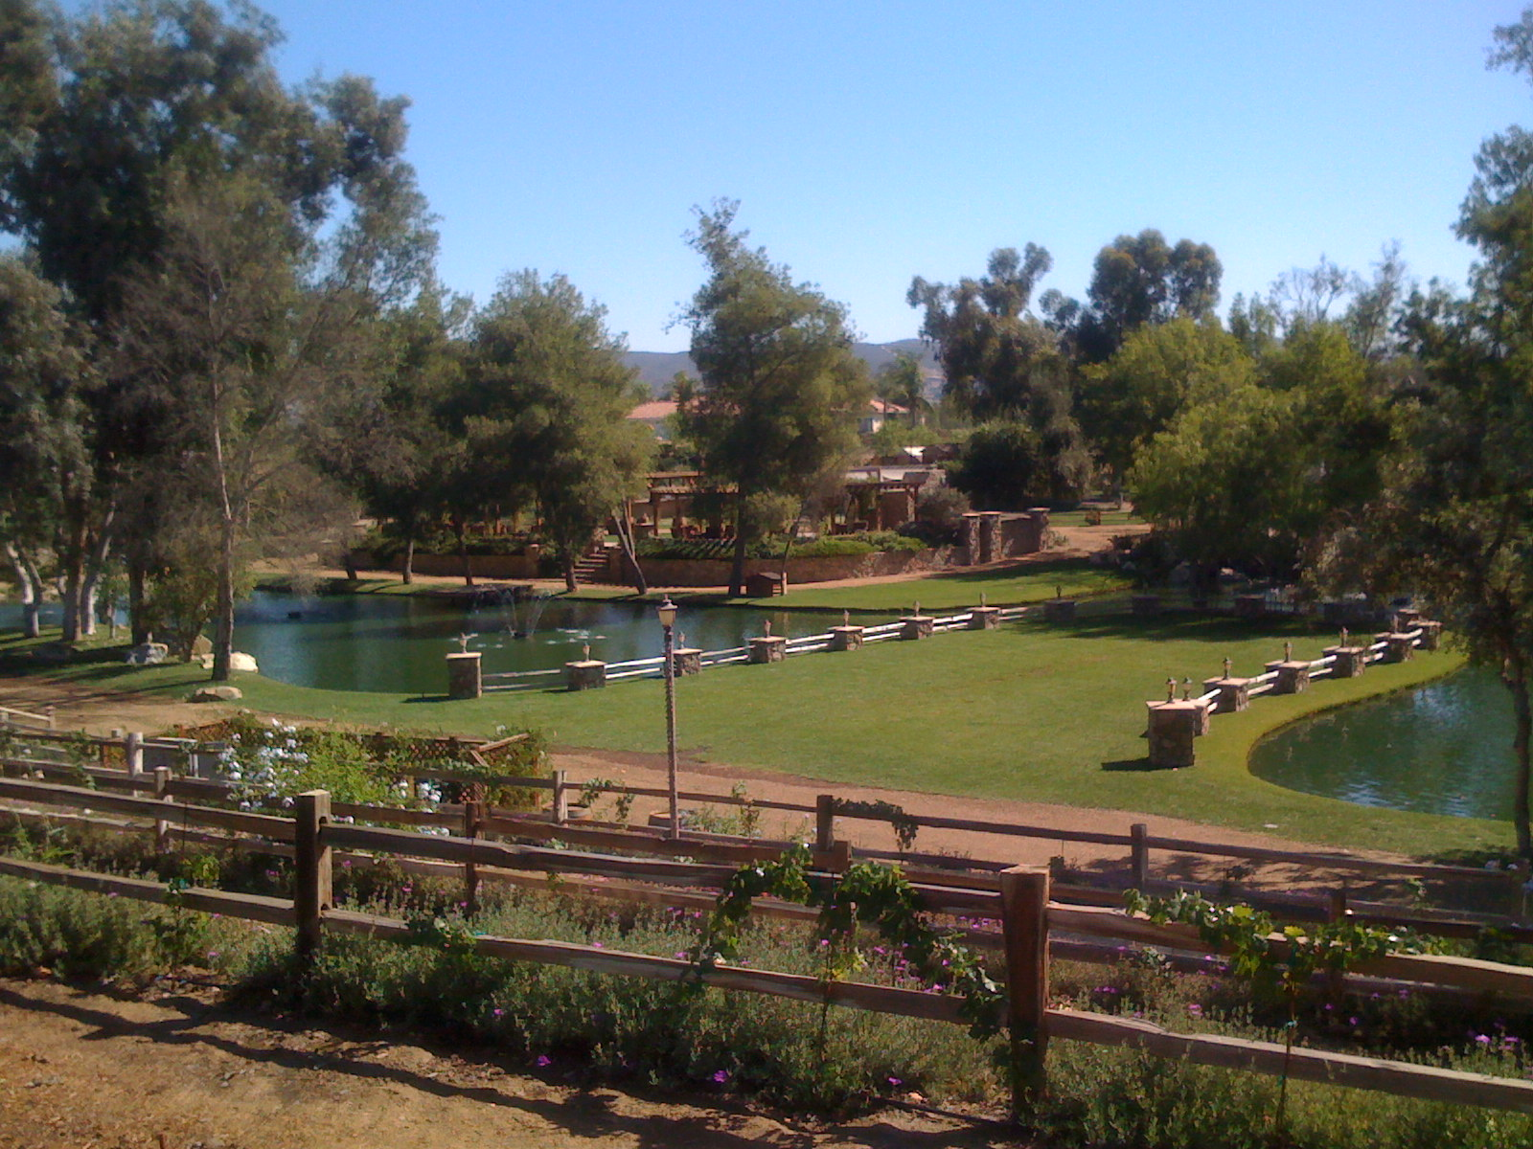
Winery Row will include a four-acre Event Center for weddings, concerts, and corporate functions. It will also serve as a major amenity for the benefit of all Winery Row tenants.

Upon completion, the event center will be utilized for a wide variety of private parties and events. Accordingly, the project will generate approximately $800,000 in annual cash flow, and achieve a market valuation of $8,000,000 based on a 10% Capitalization Rate.

Investment Opportunity

Winery Row is actively seeking strategic partners for its Master Planned development in Paso Robles, CA. Winery Row fills a need in the market for small-scale wine production, barrel storage, tasting room, and event facilities in California’s Central Coast. Demand is high in this market niche, and the demographics for wine tourism are strong. As a result, a well-planned development will provide a safe, secure and highly profitable return on investment.

Project Time Line

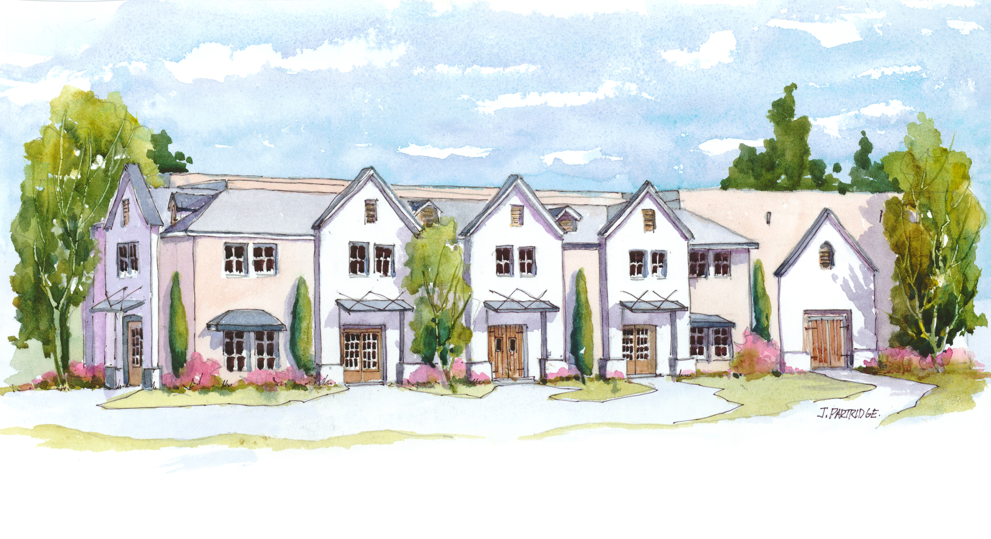
This project began in 2005 with the acquisition of a 107-acre tract of land across the street from the Paso Robles Regional Airport. By October 2008, the property had been subdivided into multiple lots.

Based on Paso Robles' ranking as the third largest wine production region in America, it was clear that the highest and best use of the property would be to build a Master Planned Mixed Use Development that promoted tourism and catered to the specific needs of the wine industry.

Plans for Winery Row were submitted to the City of Paso Robles in June 2009. The project received widespread support from the Paso Robles Planning Commission, and in September 2009, Phase I of Winery Row received unanimous approval. Based on the overwhelming support of the community, a $4,000,000 in capital improvement campaign (including streets, curbs and gutters, sewer and storm drains, and utilities) was undertaken.
In 2014, with substantially all of the infrastructure improvements complete, project architect, Larry Gabriel, was authorized to proceed with construction documents for the first winery on Winery Row. Construction drawings are nearing completion, and the first winery is expected to break ground on July 1st of 2015. Construction on the first winery on Winery Row will be completed in January 2016. Shortly thereafter, construction on the rest of Winery Row will begin.

It is anticipated, that all of the components of Winery Row will be completed by 2018.

Chris Hoskins – Bonded Winery Owner/Real Estate Developer

The managing member responsible for developing Winery Row is Chris Hoskins. As a bonded winery owner and real estate developer, Chris will direct resources and draw upon his relationships with local architects, engineers, contractors, banks, real estate brokers and city agencies to maximize returns and ensure Winery Row reaches its full potential.


Chris purchased his first real estate investment in 1985, as a freshman at California State University Fullerton (CSUF). The property – a six-unit apartment building – was in poor condition and required extensive improvements. Within a year, Chris completed the work, leased the property and sold the building for a substantial profit. Over the following 30 years, Chris became an expert at acquiring distressed properties, renovating them, and turning them into profit centers. During the early 1990’s, Chris took advantage of the Savings & Loan Crisis by acquiring, renovating, developing and managing almost one thousand apartments. In 1998, Chris built his first self-storage project, and in 2005 Chris launched his first Custom Crush winery. Today, Chris owns and manages a $40 million real estate portfolio that includes developments in California, Colorado, Texas, Pennsylvania and Central America.

Next Step

Interested parties should request a meeting with Chris Hoskins. Potential partners are also encouraged to visit the property and see the development opportunity first‐hand. Information requests may be directed to:

Chris Hoskins – Managing Member
58 Cormorant Circle, Suite 100
Newport Beach, CA 92660
Phone: (714) 470‐6400
Email: ckhoskins@aol.com
Website: www.WineryRowPaso.com

